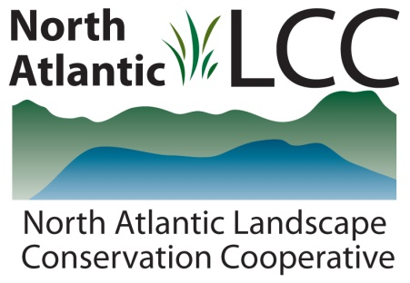

**Connecticut River Watershed Landscape Conservation Design Pilot**

|  |  |
| --- | --- |
| Project Name | ***Resilient Sites for Terrestrial Conservation in the Northeast and Mid-Atlantic Region*** |
| Product Type | GIS settings data with attributes and ranked sites. Extensive report explaining goals, process, limitations, and ranks. |
| Product Description | For this set of products, resilience refers to the capacity of a site to adapt to climate change while still maintaining diversity, but does not assume that the species currently located at these sites will necessarily be the same species present in the future.  There are three basic parts: 1) representation of geophysical settings (characterized by information on geology, elevation, and landforms) in a conservation network; 2) landscape complexity including landform variety, elevation range and wetland density; and 3) landscape “permeability” including local connectedness and regional flow patterns.  Metrics are calculated for a 13-state U.S. region and the Maritime Provinces of Canada and results show sites with the highest estimated resilience within each ecological region. |
| Geographic Extent and data scale | 13-state U.S. region and the Maritime Provinces of Canada  1000-acre hexagon sites with 30 meter cell resolution base layer data |
| Developer | The Nature Conservancy, Eastern Conservation Science Office |
| Contact | Mark Anderson and Melissa Clark, and Arlene Olivero Sheldon |
| Completion | Report and data layers from 2012 |

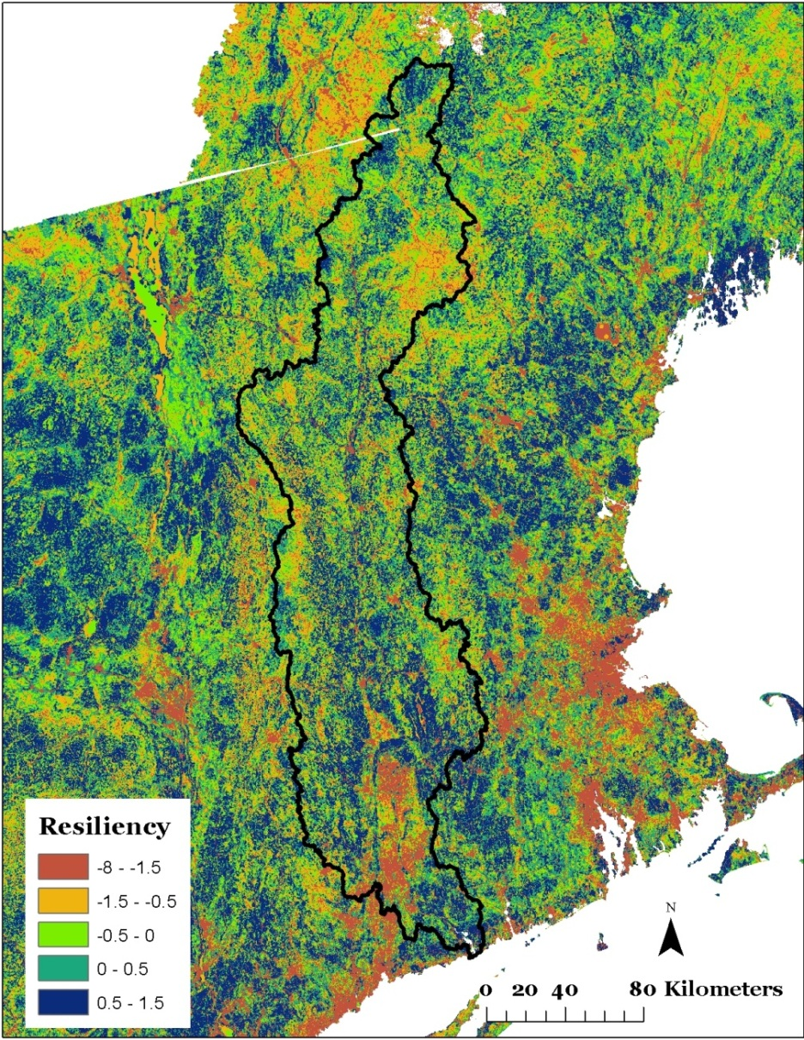

TNC Resiliency