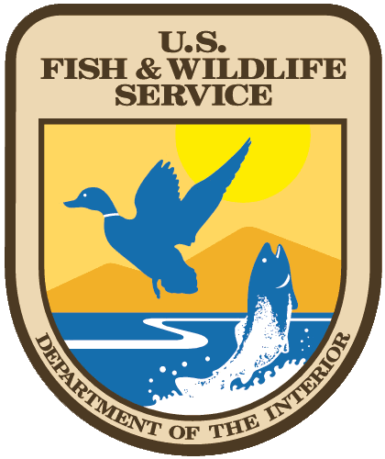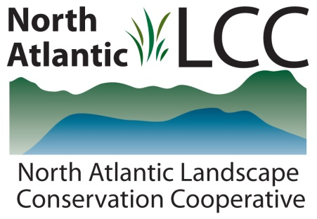

**Connecticut River Watershed Landscape Conservation Design Pilot**

|  |  |
| --- | --- |
| Project Name | ***Northeast Aquatic Connectivity: An Assessment of Dams on Northeastern Rivers*** |
| Product Type | GIS datasets and tool, Excel tool with input data, and high priority dams for removal. Report. |
| Product Description | The fragmentation of river habitats through dams and poorly designed culverts is one of the primary threats to aquatic species in the United States generally causing loss of access to quality habitat for one or more life stages of a species. The goal of this project was to assist others in efforts to strategically reconnect fragmented river, stream, coastal, reservoir, lake and estuarine habitat by removing or bypassing dams key to fish passage. A total of 72 metrics from five metric categories - Connectivity Status, Connectivity Improvement, Watershed and Local Condition, Ecological, and Size/System Type – were selected and used in the analysis. These metrics were calculated in a GIS and used to assess each dam for its potential benefit to anadromous and resident fish if removed or bypassed. Anadromous fish habitat data was the metric to which the Workgroup assigned the most weight.  Results can be viewed as a sequential list of dams grouped into 5% tiers for reporting based on the best available region-wide data and methods as of the writing of the reporting August 2011 and only examining ecological criteria.  Four datasets: dams, natural waterfalls, anadromous fish habitat, and the 1:100,000 scale NHDPlus hydrography data form the core of the project.  The Northeast Aquatic Connectivity Tool was developed to execute the weighted ranking process, to allow users to re-rank dams at multiple spatial scales (e.g. region, state, watershed), The NCAT is an Excel 2007 tool that comes pre‐loaded with an all input data. |
| Geographic Extent / scale | The region covered by the thirteen northeastern states. 1:100,000 scale hydrographic data. Local dams information. |
| Developer | The Nature Conservancy - Eastern Freshwater Program, Brunswick, ME |
| Contact | Erik Martin, Colin Apse |
| Completion | 2011 |

 