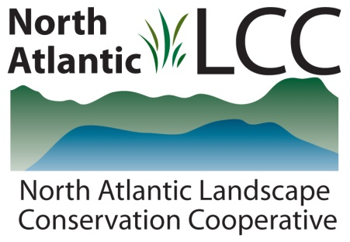

**Connecticut River Watershed Landscape Conservation Design Pilot**

|  |  |
| --- | --- |
| Project Name | ***Ecologically important floodplain forests in the Connecticut River watershed*** |
| Product Type | GIS data layer and associated report identifying site locations, site conditions and ecological significance |
| Product Description | Floodplain forests and related riparian communities provide critical habitats for a variety of plants, mammals, birds, reptiles and invertebrates. During spring floods, silt laden waters replenish floodplain soils and serve as feeding and nursery grounds for fish. The once magnificent and extensive floodplain forests of the northeast have been severely reduced to isolated fragments by agricultural clearing, road building and hydrologic alteration. The aim of this project was to identify high quality existing examples and the best opportunities for restoring floodplain forest systems in the Connecticut River watershed. |
| Geographic Extent and data scale | Connecticut River basin from the New Hampshire headwaters down basin to the head-of-tidal saltwater influence in south-central Connecticut. Boundary and attribute data for 29 of the most important floodplain sites comprised of 289 polygon elements on 25 named rivers. |
| Developer | TNC – Connecticut River Program |
| Contact | Kimberly Lutz, Christian Marks |
| Completion Date | 2011 using data collected in 2009 and 2010 |

