Title: Scaling SECAS: Engagement is Key

Author: David Whitehurst ⁽¹⁾ and Jean Brennan ⁽²⁾
Affiliation (1) Virginia Department of Game and Inland Fisheries (2) US Fish and Wildlife Service
City, State (1) 7870 Villa Park Drive, P.O. Box 90778, Henrico, VA-23228-0778; (2) 698 Conservation Way, Shepherdstown, WV 25443

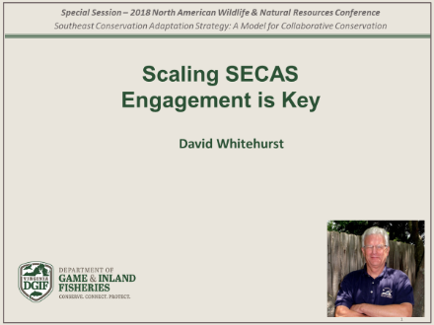
ABSTRACT: This is the last of a series of talks focusing on the Southeast Conservation Adaptation Strategy (SECAS): a state-led effort across to guide a regional conservation approach and to help fish and wildlife species and habitats adapt to future conditions. This approach was initiated in recognition of competing demands by an expanding human footprint and associated habitat losses and changes and promotes the dialogue necessary to plan, prioritize, and implement conservation actions at multiple scales. It represents a unique Model for Collaborative Conservation that combined input from multiple landscape partnerships to examine future trends and prioritize natural systems to conserve, based on their ecological and conservation values and connectivity at a regional-scale. The SECAS is not just the map or ‘blueprint’, it is actually a framework to present the conservation-valued areas as a way of rallying support and partnership, but more so to frame the critical job of prioritizing and planning across jurisdictional boundaries and land ownership, and the missions and mandates of land and natural resource management agencies (i.e., those working with state and federal fish and game organizations and federal or military installations), and land stewards (i.e., those working with parks and land trusts). This Strategy should assist in recruiting a broader suite of partners necessary to strategically identify focal areas, to complete conservation design for these areas, and to implement appropriate conservation actions. Successful adaptation of the conservation challenges of this Century will require the engagement of new, and some unfamiliar partners. This strategic blueprint or framework should greatly assist potential partners in recognizing the critical roles for their participation in this regional landscape - – be they lands held to generate economic growth, recreation properties or military installations-- to sustain our fish, wildlife, and natural resources and systems into this century. This paper focuses on this last element, engagement, as a critical element to fully realize the potential and successfully scale the SECAS approach across multiple scales.

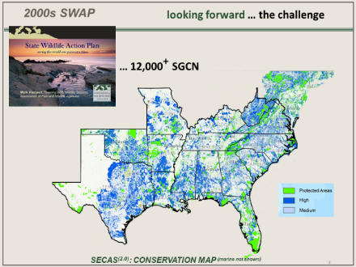
Looking forward, we see that SECAS provides an excellent model to address the large-scale regional challenges of the 21st Century. The first benchmark in our transformation to a new conservation approach dates to the release of the first State Wildlife Action Plans (SWAPs) in 2005. An integration of these 56 plans by the states and provinces produced a national measure of the scale of the challenge –viewed in terms of the staggering number of over of over 12,000 species already in sharp decline. These “species of greatest conservation need” (SGCN) quickly led to the stark realization that addressing that scale of threats without adopting a dramatically different approach. Obviously, the collective actions of the conservation community were not adequately addressing the needs, and were not going to work, given the ever-expanding challenges of increased development, expanding human population demands on land and natural resources, and observed trends in climatic changes. SECAS provides a second benchmark: to frame our conservation action and implementation approach going forward. But, as the prelude implies, if we are to address this challenge nationally we must expand – to scale-up the model – to build the necessary national support to sustain this way of working. This paper makes an initial effort to consider scaling-up the SECAS model as our third benchmark in transitioning to a more effective, relevant, and ultimately successful North American conservation approach. Specifically, the paper will: (1) look at the history and guidance leading up to this point in our conservation journey toward a REGIONAL approach to conservation, (2) consider the need to take the regional SECAS ‘blueprint map’ down to the STATE or LOCAL level, and then (3) raise the focus to scaling the collaborative model up to a NATIONAL level. The main thesis of my remarks is that our profession – the fish and wildlife profession—is transitioning from a business model of ‘natural resource management’ to one of ‘collaborative landscape conservation’ to achieve our missions and mandates.

- Look at history and guidance leading us to this Regional perspective in our conservation journey
The use of the term “business model” is central to this paper as it serves to remind our professional membership that we are a business. Some people in this profession may feel that this term is inappropriate given the “higher calling” and “working towards the benefit of the greater good” that many of us feel; however, ours is a profession of service. But, as a business we survive or fail based on: (1) the value-added services and products we provide (to society as our client); (2) our competitiveness in a rapidly changing environment (referring to changing social values and competing demands for social services like transportation, military readiness, access to medical care etc.); and (3) how we choose to position ourselves within this external environment if our business is to meet future needs (i.e., how we allocate capital and human resources and plan our work – to be strategic or continue on our more opportunistic path.) The call to reconsider our business model is not new. Earlier authors and speakers challenged us to rethink our business model on two fronts: our target and how we articulate and explain our business to both our external and internal audience.

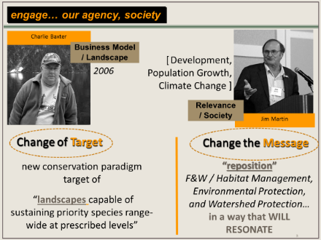
The first reference is that of Charles (Charlie) Baxter in his “Open Letter to the Directorate” in 2006. Charlie shared his observations with his U.S. Fish and Wildlife Service leadership that the conservation path we are on (primarily as a natural-resource focused model of harvest and yield) would never be able to address the conservation of non-game species in decline. More of our conservation charge would be heading toward listing under the Endangered Species framework – and acknowledging our inability to keep pace with it now, let alone hope to meet an escalating need in the future. The only hope was to get ahead of the need: to shift to a proactive vs. reactive approach instead of chasing behind in an ever-expanding wake of species decline and loss. The “target” as noted needed to change to focus on protecting, restoring, and connecting “landscapes capable of sustaining priority species range-wide”. That is, conservation should be treated fundamentally a multi-scale endeavor – to reconcile site-scale actions with landscape-scale processes and functions” and we needed to move “from the opportunistic to the strategic”. Our agencies need to plan and work at a landscape-level based on the best predictive knowledge of changes in land-use, human population growth, and impacts of changing climate conditions. Charlie’s letter greatly influenced Sam Hamilton’s thinking as he became Director of the Fish and Wildlife Service and played a significant role in the adoption of the Strategic Habitat Conservation (SHC) approach and creation of the Landscape Conservation Cooperatives.

The second reference is to Jim Martin, formerly with Oregon Fish and Game, who spoke at this same Conference in 2006 in Columbus, Ohio. He called upon our profession to change our messaging: to “reposition” how fish and wildlife management appears in the public perception – i.e., how we articulate our business model “in ways that will resonate” with a society that does recognize and value ‘environmental’ and ‘watershed protection.’ “We need to have the credibility and public support to influence land-use decisions in favor of wildlife resources – but usually through the lens of ecosystem viability, services, etc.” People understand how these “value-added services” impact their lives and quality of life now and that of their family’s future.

- “Scale-down” regional information displayed in the ‘blueprint’ (map) to state/local level
SECAS is a great State-supported initiative and the ‘blueprint’ map offers a valuable framework to initiate planning and decision-making discussions as the earlier speakers in this session have pointed to, in helping others make large, regional investments. But ‘scaling-down’ regional maps to the state or local level requires much more: it requires a finer look into the underlying data or modeling approach to define connectivity. This section examines some of the factors that States may wish to consider when it comes to scaling down the SECAS blueprint. The first is how areas were identified as conservation priority sites and how those align across state-, regional- and jurisdictional-boundaries.

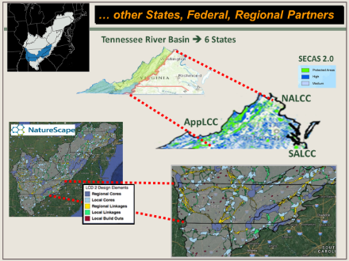
(a) aligning LCC-defined geography & targeting cross-state or cross-jurisdictional collaboration. Overcoming the first hurdle of aligning differing scientific approaches in one geospatial representation has been demonstrated through the SECAS effort in creating the one regional map across six LCCs. In the case of the state of Virginia, we can recognize at least three major areas. The Western area was part of the Appalachian Landscape Conservation Cooperative (LCC) with its mountain habitats and biodiverse aquatic rivers and stream. The central and coastal marine shores to the east were focal regions of the North Atlantic LCC and the southern piedmont region was part of the South Atlantic LCC. Each LCC pursued independent landscape conservation design approaches but many of the underlying data sets captured similar environmental metrics. The ‘unifying’ aspect of utilizing the SECAS map is that it allows this sort of blending between differing scientific approaches. Conservation design created by the Appalachian LCC and the SECAS blueprint clearly identified the conservation importance of the Tennessee River Basin (TRB).

To illustrate the finer factors, the Appalachian LCC, in its efforts to “scale down to earth” completed finer scale modeling for the (TRB). The resulting landscape conservation design is referred to as “NatureScape”. The next hurdle at the State level is using the SECAS framework to engage other State, Federal, and conservation partners. In our example the TRB spans parts of 5-states, and almost all of Tennessee. In the case of Virginia, it represents a little less than a third of our geography but is home to almost half of our threatened or endangered listed species (47.2%), many of which are endemic. This finer-scale and partner-prioritized modeling output map represents similar information: local rich conservation areas joined by connectors to facilitate species movement and habitat migration over time, given future modeling predictions on expanding urbanization, energy development, change in hydrology and precipitation under future climate conditions and watershed scores based on human development index. The value of these future geospatial designs is that it allows us to follow as Baxter has pointed out, the need to get ahead of expanding changes and work across jurisdictional boundaries with a suite of state and federal partners to secure today, the habitats and connectors that we will need for tomorrow.

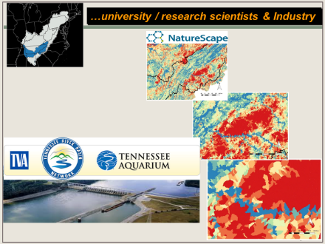
(b) engage land-use decision-makers and non-traditional corporate partners. Using the TRB to illustrate a state agency perspective, we can draw up the lessons already learned through our previous LCC partnerships. The geographical design for a landscape-based conservation focal area must have an ecological basis, and key partners must have meaningful input in developing the geographical footprint. This is especially true for state fish and wildlife agencies and our leadership; to understand what is happening within smaller sub-regions the partnership chooses to focus its planning and conservation delivery upon. This also allows the conservation partners to identify key sectors and actors to strategically engage. In the TRB example, we work closely with representatives of the Energy Sector through the Tennessee Valley Authority (TVA) that share the mission of delivering healthy watersheds. From the TVA perspective, that ensures their mission to deliver reliable hydro-electrical power. From the Fish and Wildlife agency perspective, that ensures the riparian and freshwater ecosystems that sustain countless numbers of endemic and imperiled aquatic species. It also allows our researchers to apply more detailed datasets to future modeling and impact assessments as a reduction in area increases the chances of having common datasets across the entire modeled geography (i.e., modeling must have end-to-end data layers to ensure an unbiased projection.) But although this level of detailed explanation may serve to engage our research and management audience, our more sustained conservation efforts rely on our ability to engage local communities, land-use planners and decision-makers.

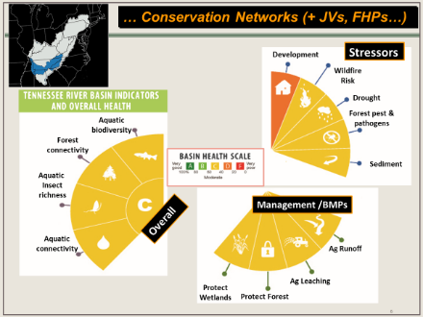
(c) support or help build local conservation networks and build sustainable local support. Engaging this broader audience in communicating our business model message is critical. The TRB is an excellent case study of how we see the expanded role of state wildlife agencies going forward: to communicate the value-added services and products our work delivers to the broader society. But most importantly, we have also learned that our ability to spread that critical messaging can only be possible by tapping into existing, or helping to codify, conservation networks. The scope of the work exceeds the staffing and resources available to any state or regional conservation entity. We must work through and support local networks, local partners. In the case of the TRB we are also fortunate to be able to engage local environmental education and recreational institutions like the Tennessee Aquarium to help spread the news of both the need and the opportunities for local engagement and support towards local conservation that contribute to a broader regional impact. We relied on the research conducted by the University of Maryland to create a “Report Card” for the region. It served not only as a tool for managers to prioritize on-the-ground actions, but also provided a general and easily understandable outreach tool to engage networks, watershed groups, local communities etc. to join our conservation effort.

- “Scale-up” SECAS to raise the focus of adopting a collaborative model up at a national-level
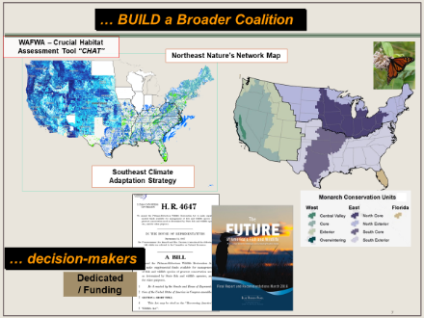
SECAS has provided a promising model for regional conservation but given the scale of the challenge we need to work towards achieving our third benchmark: a national framework. The Southeast Association of Fish and Wildlife Agencies has rallied around the SECAS model, as have the Northeast Association of Fish and Wildlife Agencies in the development of its Regional Conservation Needs (RCN) program that supported research and design (Natures Network). In the West, the Western Governors Association and the Western Association of Fish and Wildlife Agencies have supported the Critical Habitat Assessment Tool (CHAT) that also presents a regional conservation design. The Mid-West Association of Fish and Wildlife Agencies has demonstrated a single-species regional (as part of an international) conservation initiative in leading the monarch conservation strategy. We as a nation are well poised to reach our final benchmark if we work together, across regions, to create a seamless design, a network of regional conservation partnerships, supported by local-networks and communities.

The challenge has been recognized. Our Regional Associations have demonstrated their ability to organize and plan at this larger regional-scale. We now need to rally support of a broader coalition as has been presented as the results of a 2016 Blue Ribbon Panel on Sustaining America’s Diverse Fish and Wildlife Resources; an independent body made up of industry, business, researchers, sportsmen’s group, resource agency directors, environmental lawyers and non-profit conservation groups. Their charge was to consider our challenge: how to sustain America’s diverse fish and wildlife resources. Not surprising results from a business-savvy group in their conclusions: first, invest proactively rather than reactively and “examine the impact of societal changes on the relevancy of fish and wildlife conservation and make recommendations on how programs and agencies can transform to engage and serve broader constituencies.” The Panel also stressed the need for dedicated funding, at a national-level and the “Alliance for America’s Fish and Wildlife” has taken up the charge to promote this effort. SECAS plays an important role in demonstrating to national leaders and Congress that this vision is well within our grasp.

- Essential elements to frame our engagement at all scales
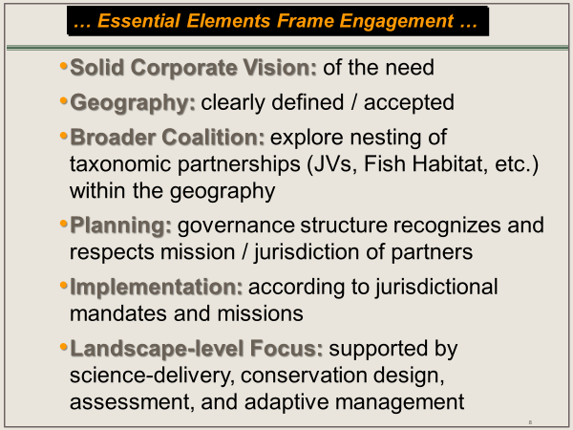
Our charge – “engage” – is the sustaining force that flows between all levels, at all scales. It is the factor that determines the success or failure of our new business model. As Baxter noted: “one of the principal tenets of management theory (is) many businesses fail or decline because the assumptions that underlie their decisions (about society, markets, customers, products, technology, and mission) are made obsolete, invalid, or irrelevant by a constantly changing business environment (pg 17).” To review what we have learned from almost a decade of work through the LCC partnership, I will offer a few essential elements to advance this new conservation model by engaging old and new partners in this important work.
Essential elements for successful, national implementation of this business model:
- solid corporate vision of the need,
- clearly defined and accepted geography,
- well established governance structure that recognizes and respects mission and jurisdiction of partners,
- build a broader coalition including nesting of taxonomic partnerships (such as the bird joint ventures or fish habitat partnerships, TRB network, etc.) within the geography, if possible,
- landscape level focus is on science-delivery, conservation design, assessment, and adaptive management; partners implement according to mandates and missions.

We have a great opportunity before us. The opportunity to come together to jointly define our new path, our new business model. But there is no time to waste. Our profession is in a period of significant change, thousands of species are in serious decline. Factors associated with that decline have been identified: habitat loss and fragmentation, invasive species, population growth and associated development, climate change. These impacts are occurring on an ecological scale. Baxter and Martin clearly stated the need to change to a landscape-based business model, and we have collectively taken steps to move to such a model. Others are working to secure the funding necessary to reverse the decline of the nation’s wildlife, and this coalition can also play a pivotal role in increasing participation in landscape scale conservation efforts.

References Cited:
Baxter, Charles M. “Responding to the Changing Nature of Conservation: An Open Letter to the Directorate on Shaping the Service Future.” 2006. Pp.25.

Blue Ribbon Panel on Sustaining America’s Diverse Fish and Wildlife Resources. “The Future of America’s Fish and Wildlife: A21st Century Vision for Investing in and Connecting People to Nature.” Final Report and Recommendations March 2016. Published by the Association of Fish and Wildlife Agencies, Washington, DC. Pp 11.

Martin, James T. “Development and a Changing Climate: Wildlife Caught in the Squeeze.” Opening Session: Development and a Changing Climate. Transactions of the 71st North American Wildlife and Natural Resource Conference. 2006: 12-19.

